**To: Spelman HHMI Internal Advisory Board**

**From: Zhane’ Cruickshank and Keyana Scott**

**Date: September 17, 2014**

**Subject: Letter of Intent for HHMI student proposal**

Dear Advisory Board,

We, Zhane Cruickshank and Keyana Scott, propose to use *Escherichia coli* as a model to study the mitochondrial aging, a major cause of human aging and disease. Mitochondria have a proteobacterial origin based on the endosymbiosis hypothesis. *Escherichia coli* is a model organism in the phylum proteobacteria, and therefore is informative on mitochondrial aging.

Mitochondrial aging is a main cause of human aging, because the aerobic respiration occurring inside of mitochondria produce reactive oxygen species (ROS) as byproducts. ROS are highly reactive molecules with unpaired electrons that can react with intracellular macromolecules and prevent them from performing normal functions. At the center of the free radical theory of aging lies the very important role of the mitochondria.

The free radical theory of aging states that highly reactive molecules with unpaired electrons, termed as free radicals, cause oxidative damages to macromolecules within cells; thereby hindering normal biological functions. Mitochondria produce more reactive oxygen species such as superoxide radical and hydroxyl radical. These oxygen species with unpaired electrons are highly reactive and can damage the mitochondria’s DNA and proteins. The damaged mitochondria will then produce more ROS. This vicious cycle gradually leads to catastrophic consequences and is a major cause of aging.

*E. coli* is a great model for mitochondria because they reproduce in the same manner. *E coli* is an organism with asymmetric division, no juvenile phase, and no identified separation between germ line and soma; making it still susceptible to aging. Ituses asymmetric division that will exhibit no distinction between the parent and offspring. This division requires an old pole from the parent cell and builds a new pole with the occurring offspring. A Juvenile phase requires a cell to go through a time of growth or differentiation from the parent cell. *E. coli* does not demonstrate this phase and allows for immediate rejuvenation of the offspring.

We plan to use the *E. coli* gene network to model its aging process, a theoretical framework that has recently been developed in Dr. Qin’s group. Gene interactions network referrers to the entire set of pairwise interaction between genes in the *E. coli* genome. *E. coli* is a single cell organism that makes aging of its gene netw­­­­­­­­­ork a good model for the aging of mitochondria.

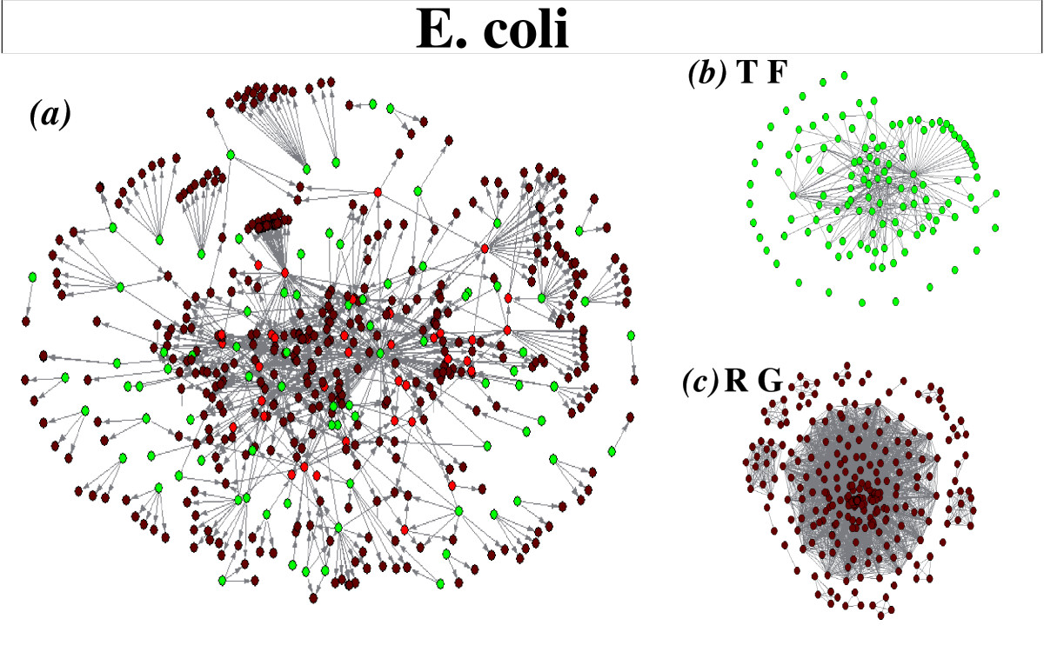Aging is defined as the increasing chance of failure with time. In a gene network, if one of the nonessential genes dies, the entire system will not fail since there are more components still performing their normal functions. Other genes can often replace nonessential genes. Only when an essential component fails will the entire gene network fail. This gene network system is a good model of cellular aging because just as with the gene network, a cell ages when its components fail and cease to perform their normal functions. As a result of the deterioration of the gene function, the cell ages and ultimately dies.

E. coli Gene Network

↓

Network Aging in E.Coli

 ↓

       Mitochondrial Aging

  ↓

        Reactive Oxygen Species

   ↓

       Human Aging

**Figure 1: Proposed research plan**

­­­To test our modeling work, we will compare the aging process of the E coli gene network with experimental data. We will implement this modeling work in the open source language R environment.

**Keyana Scott**

**Zhane’ Cruickshank**

**Spelman College**

**Biology Majors**

**Class of 2016**

**Contact information:**

[Kscott23@scmail.speman.edu](mailto:Kscott23@scmail.speman.edu)

[zcruicks@scmail.spelman.edu](mailto:zcruicks@scmail.spelman.edu)